**Ex. 5. JavaScript – DOM Elements and Events**

**URK17CS127**

**Date:**

1. Write a function that accepts a string as a parameter and find the **shortest and** **longest word** within the string. Example string: 'Web Development Tutorial'

Expected Output: Shortest: 'Web'

Longest: 'Development'

Hint: Split a string into an array - **split()**

Find the length of a string – stringname**.length**

Find the size of an array – arrayname**.length**

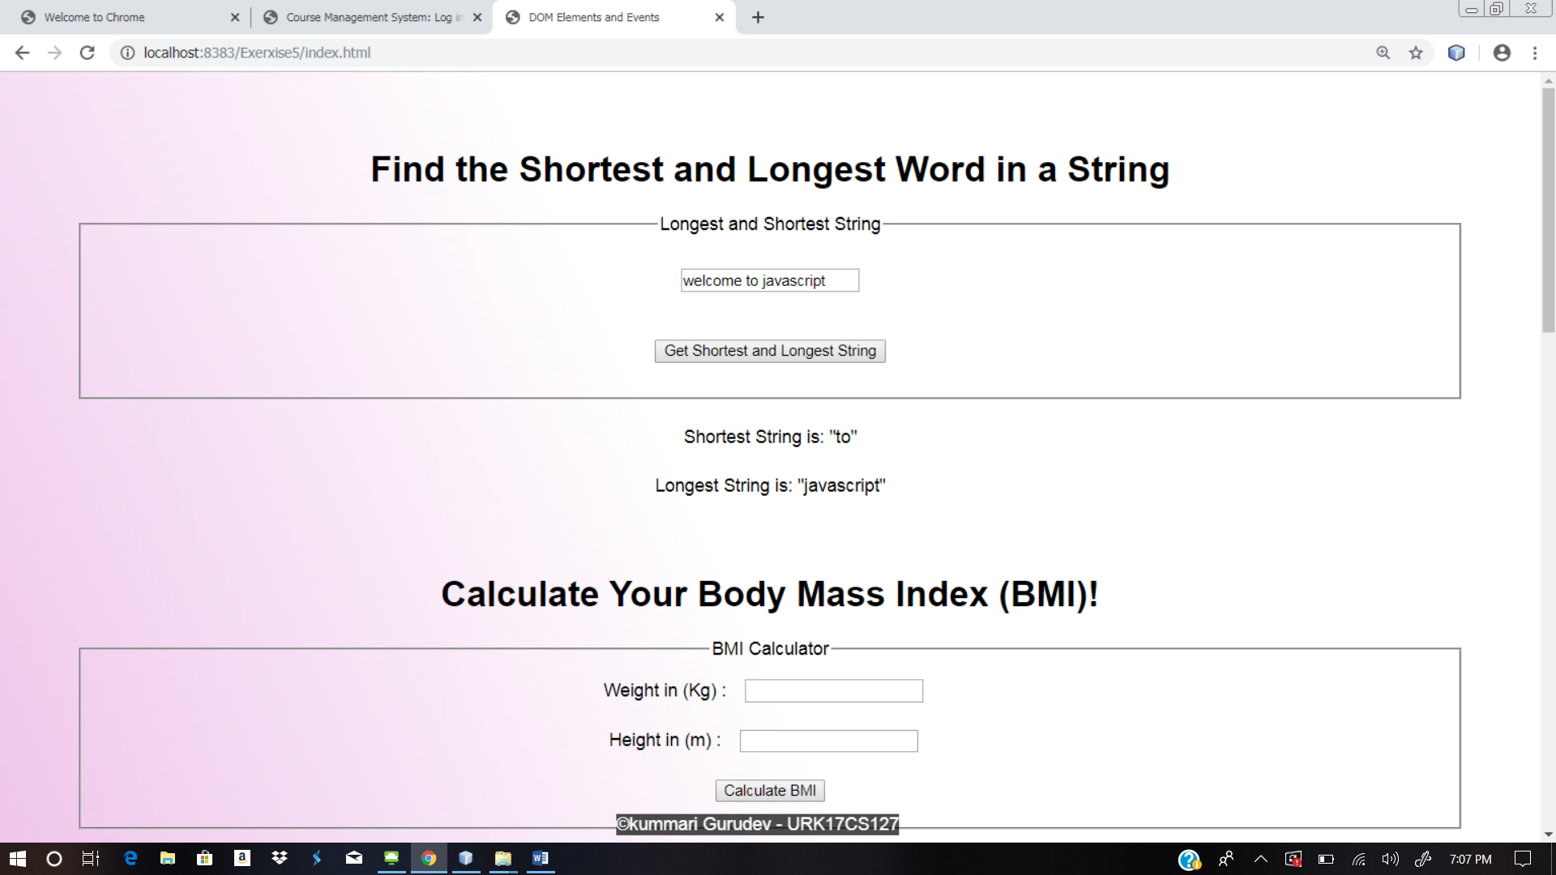

1. **BMI Calculator**: The following HTML snippet shows the skeleton of a BMI calculator. Write the calculate() function that takes the weight and height in the text boxes and displays the BMI in the span with the id of “score.” BMI is calculated from the equation: weight / (height * height). You should also describe the person’s body type based on their BMI score using the following criteria:

* Underweight: < 18
* Normal: 18 – 25
* Overweight: 25 – 30
* Obese: > 30

The person’s body type should be displayed in the span with the id of “type” and you may assume valid input into the text boxes.

|  |
| --- |
| <h1>Calculate your Body Mass Index (BMI)!</h1>  <fieldset>  Weight (in kilograms): <input type="text" id="weight" /><br />  Height (in meters): <input type="text" id="height" /><br />  <button onclick="calculate();">Get BMI!</button>  </fieldset>  <p>  Your BMI is <span id="score"></span>. <br />  Your body type is <span id="type"></span>.  </p> |

**function** calculate () {

//extract data from input box

var height = parseFloat(document.getElementById("height").value);

//change the content of html element

document.getElementById("score").innerHTML = bmi;

}

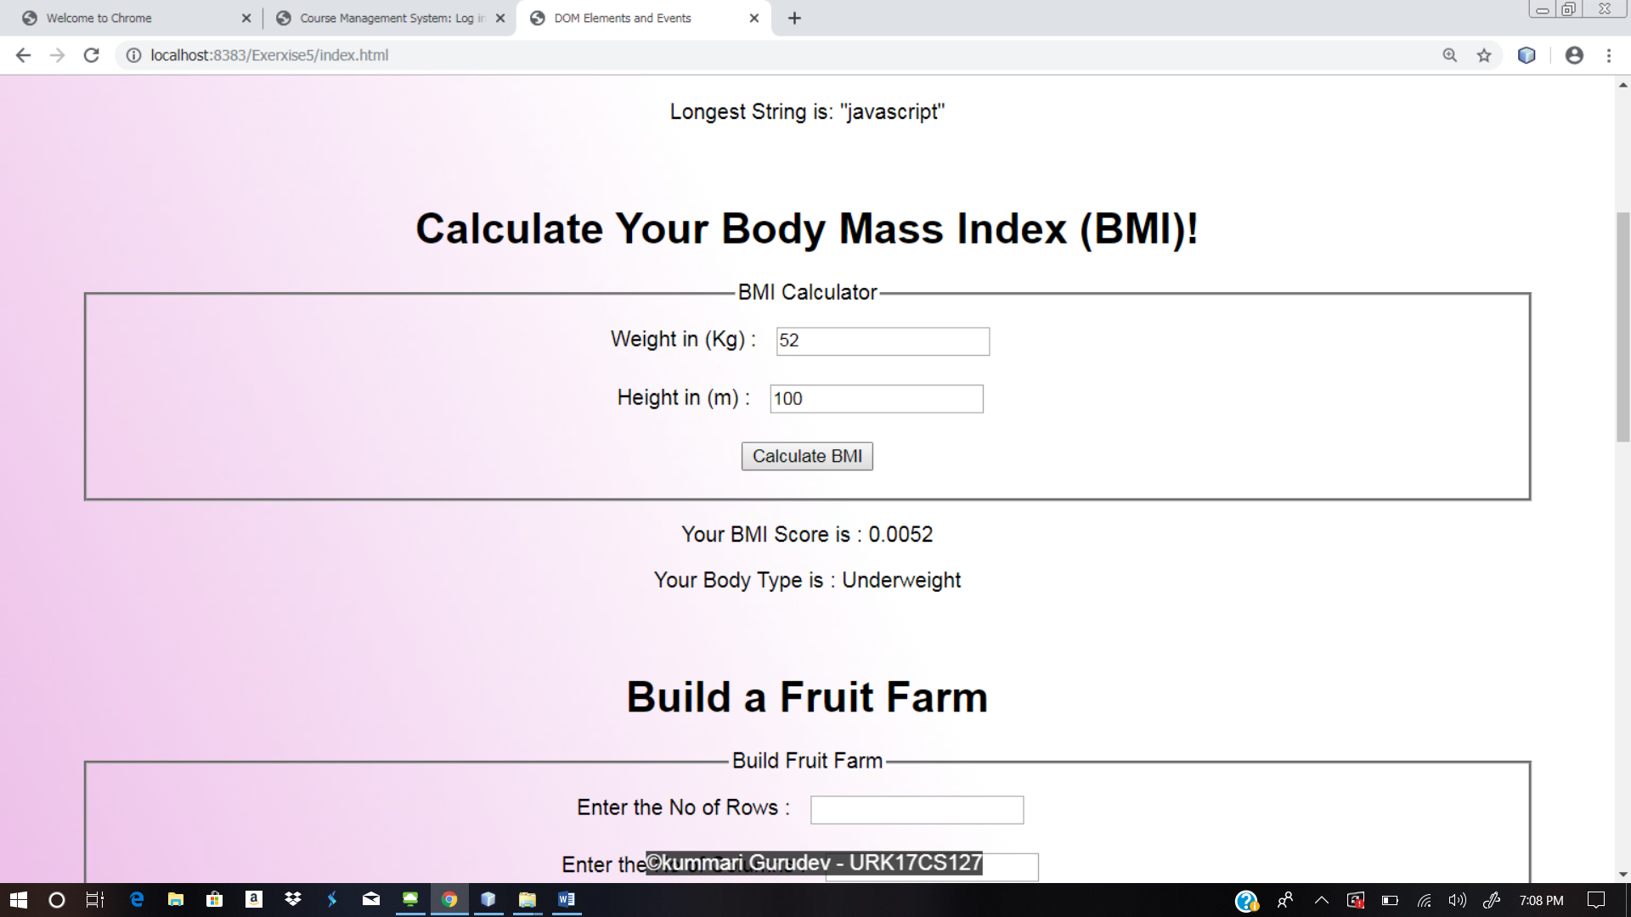

1. **Fruit Farm:** The following HTML snippet is from a webpage that allows users to design rectangular fruit farm beds. When you click the “Plant Garden” button, the page should generate a rectangular grid of fruit images in the div with the id of “garden.” The dimensions of grid are given by the values entered in the text boxes. Write the **grow() JavaScript function to complete the functionality for the webpage. You should** randomly display either “apple.jpg” or “orange.jpg” for each fruit image, and either fruit should show up with equal probability.

|  |
| --- |
| <h1>Fruit Farm</h1>  <div>  Rows: <input type="text" id ="rows" />  Columns: <input type="text" id ="columns" /> <br />  <button onclick="grow();">Plant Garden</button>  </div>  <div id="garden"></div> |

//add image

document.getElementById("garden**").innerHTML** += **"<img src= Apple.jpg width =100px height= 100px>**"; // += for appending the text

// create an array of strings

var arr = ["Orange.jpg","Apple.jpg"];

//generate random number in the range of 0 to 10

var number = Math.floor((**Math.random()** *upper bound) +lower bound);

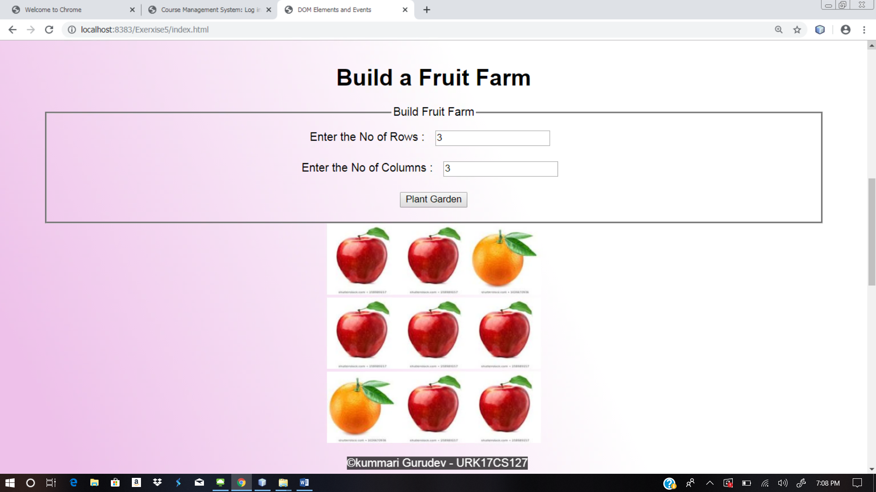

1. **The Currency Convertor**: The following HTML snippet shows the skeleton of a rupees-to-dollars, dollars-to-rupees conversion tool. Write the convert() function that takes the value in the text input and converts it from the unit selected in the left dropdown box to the unit selected on the right. The unit should be displayed in the empty span with the id of “answer.” The conversion factor from rupees to dollars is 0.015, and the conversion factor from dollars to rupees is 67.12. You should edit the HTML to add ids to the elements as necessary and you may assume valid input.

|  |
| --- |
| <fieldset> Convert <input type="text" id="data" />  <select id="from">  <option>Indian Rupee</option>  <option>US Dollar</option>  </select>  to  <select id ="to">  <option> US Dollar </option>  <option> Indian Rupee </option>  </select>  <button onclick="convert();">Calculate</button> <span id="answer"></span>  </fieldset> |

//extract value from drop down list

var index = document.getElementById("from").selectedIndex; // return index

var value = document.getElementById("from")[index].value; // return value

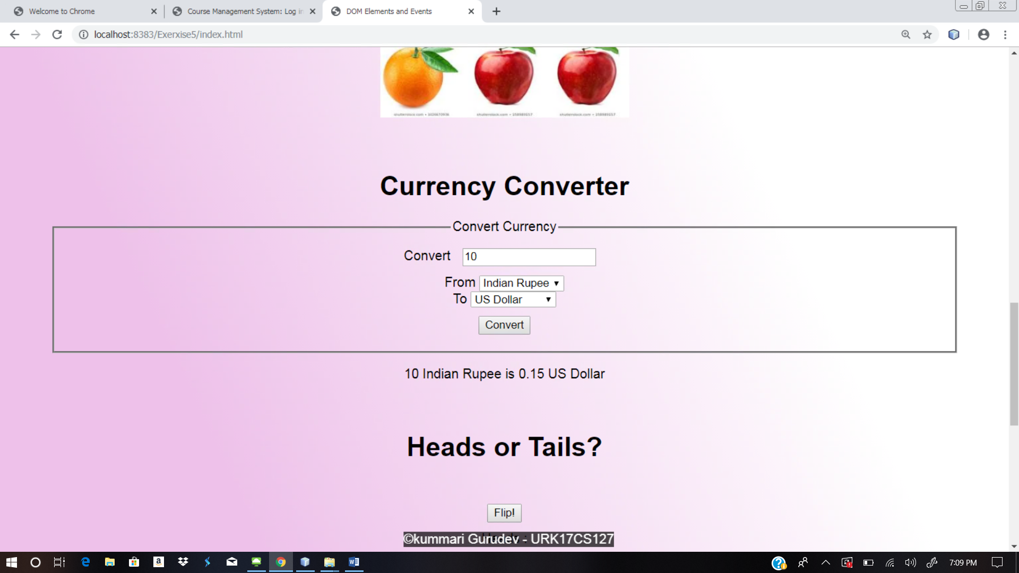

1. **Coin Flip**: Write JavaScript code to randomly change the src of the img in the HTML snippet to "heads.jpg" or "tails.jpg" when the “Flip!” button is pressed. The image should change to the heads or tails picture with equal probability. Keep track of how many flips have resulted in heads and tails and report the results beneath the button in two spans with ids "num_heads" and "num_tails" respectively. You should write JavaScript code to attach the event handler to the button and you may assume the user enters valid input.

|  |
| --- |
| <h1>Heads or Tails?</h1>  <div>  <img src="heads.jpg" id="coin" /> <br />  <button id="flip">Flip!</button>  </div>  <p>  Heads Total: <span id="num_heads">0</span><br />  Tails Total: <span id="num_tails">0</span> </p> |

// attach the event handler to the button document.getElementById("flip")**.addEventListener**("click", **flipFunction**);

**function flipFunction**() {

//code goes here

}

// change the src of the img in html

document.getElementById("coin")**.src** ="head.jpg";

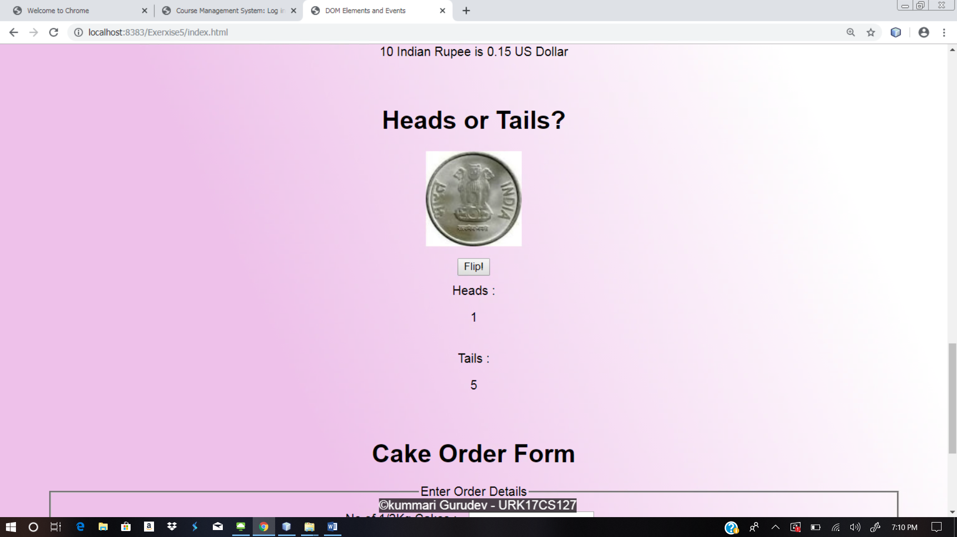

1. **Birthday Cake Order Form**: The following HTML snippet represents a skeleton of a price calculator for a cake order form. A 1/2kg cake is Rs.100, a 1kg cake is Rs.200 and a 2kg cake is Rs.400. Tax is an additional 9% to the order. The user must also pay a tip from 10-20% of the total cost of the order after tax. Write the JavaScript code necessary to calculate and display the total cost of the order in the span with the id of “price” when the user clicks the “Calculate Order” button. You should write unobtrusive JavaScript code to attach the event handler to the button and you may assume the user enters valid input.

|  |
| --- |
| <h1>Pizza Order Form</h1>  <fieldset>  # of 1/2kg Cakes <input type="text" id="small" /><br />  # of 1kg Cakes <input type="text" id="medium" /><br />  # of 2kg Cakes <input type="text" id="large" /><br />  Tip:  <label><input type="radio" value="10" name="tip" /> 10%</label>  <label><input type="radio" value="15" name="tip" checked="checked" /> 15% </label> <label><input type="radio" value="20" name="tip" /> 20%</label> <br />  <button id="submit">Calculate Order</button>  </fieldset>  <p>  Cost of order: <span id="price"></span>  <p> |

//extract value from radio buttons document**.querySelector('input[name="tip"]:checked')**.value

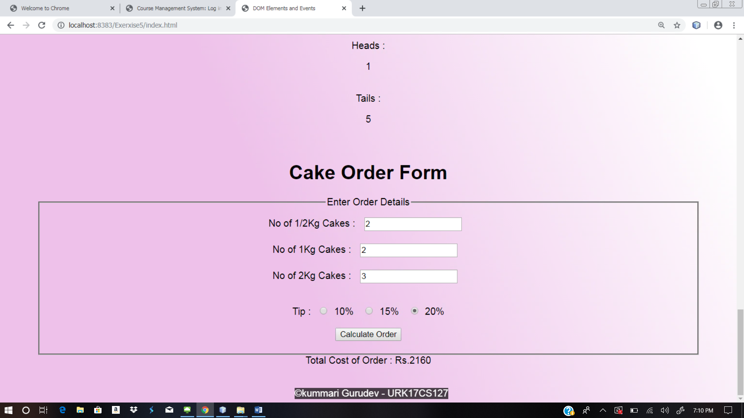

**Web site URL:** <http://urk17cs127.rf.gd/Exercise5/>

**You tube URL:** [**https://youtu.be/UP1Kn6Wp0IY**](https://youtu.be/UP1Kn6Wp0IY)